5 Visualizations On Sales Data
- Balanced Gender Distribution Across Customer Segments
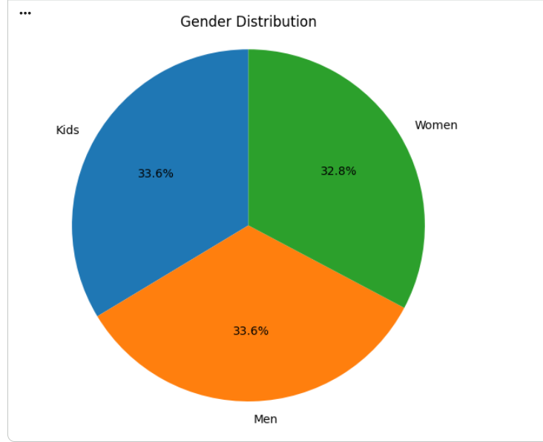
Insights:
: Kids account for 33.6% of the total customer distribution, the highest share.
: Men also contribute 33.6%, matching the Kids segment.
: Women represent 32.8%, which is only slightly lower.
: The distribution is almost evenly balanced across all three segments.
- Yearly Revenue trend Analysis(2020-2025)
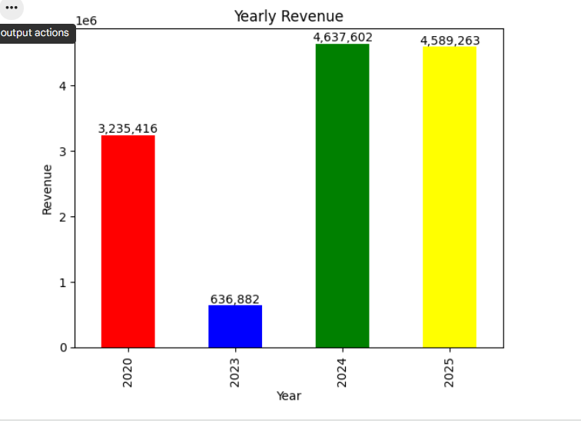
Insights
: 2024 recorded the highest revenue at 4,637,602, making it the best-performing year.

: 2025 followed closely with 4,589,263, showing revenue remained consistently strong.

: 2023 had the lowest revenue at 636,882, indicating a significant decline compared to the other years.

: Revenue increased sharply from 2023 to 2024, suggesting strong business recovery and growth.

Overall, the business achieved higher revenue performance in the most recent years (2024–2025).
- Units Sold By size Analysis
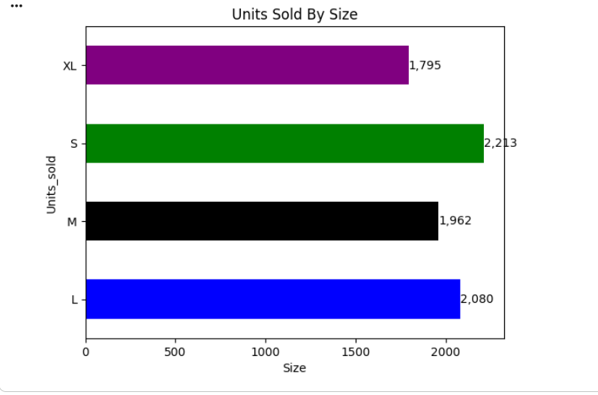
Insights
: Size S recorded the highest sales with 2,213 units, making it the most popular size.

: Size L ranked second with 2,080 units sold, showing strong customer demand.

: Size M sold 1,962 units, indicating moderate demand.

: Size XL had the lowest sales at 1,795 units, suggesting comparatively lower customer preference.

: Overall, demand is highest for smaller and medium-sized products, while XL has the least demand.
- Revenue By Product Line Analysis
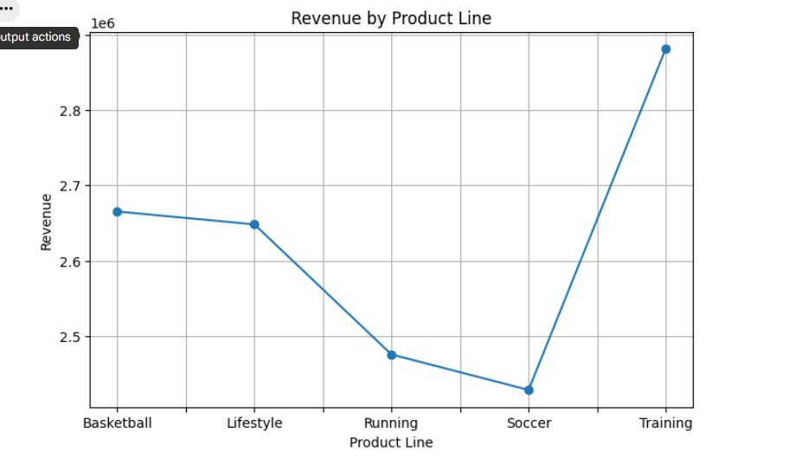
Insights
Training generated the highest revenue (approximately 2.87M), making it the top-performing product line.

Basketball ranked second with around 2.67M in revenue.

Lifestyle followed closely, contributing approximately 2.65M.

Running generated moderate revenue (around 2.48M).

Soccer recorded the lowest revenue (approximately 2.43M), indicating the weakest performance among all product lines
- Region_wise Revenue by Sales Channel Analysis
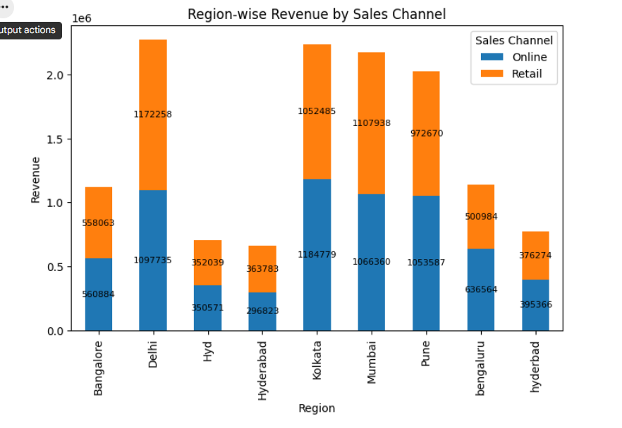
Insights
Delhi generated the highest total revenue, with both Online and Retail channels contributing almost equally.

Kolkata and Mumbai were also among the top-performing regions, showing strong revenue from both sales channels.

Pune recorded consistently high revenue, with balanced contributions from Online and Retail sales.

Bangalore, Hyderabad, and Hyderabad generated comparatively lower revenue than the top-performing regions.

Across most regions, Online and Retail sales contributed nearly equally, indicating a well-balanced sales strategy without heavy dependence on a single channel.

